Level 1: Android Studio Setup
Task 1 = Install Android Studio & SDK
Step 1: -
Open any browser (Crome, Opera, Brave, Edge, etc.)
Step 2: -
Search "google documentation android studio setup" (always look for official documentations)
Step 3: -
Go for the “Android Developers” link
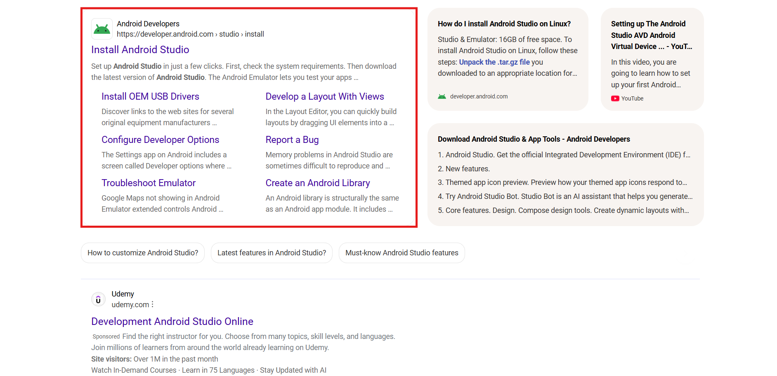
Step 4: -
Open the link and look for “download the latest version of android studio”
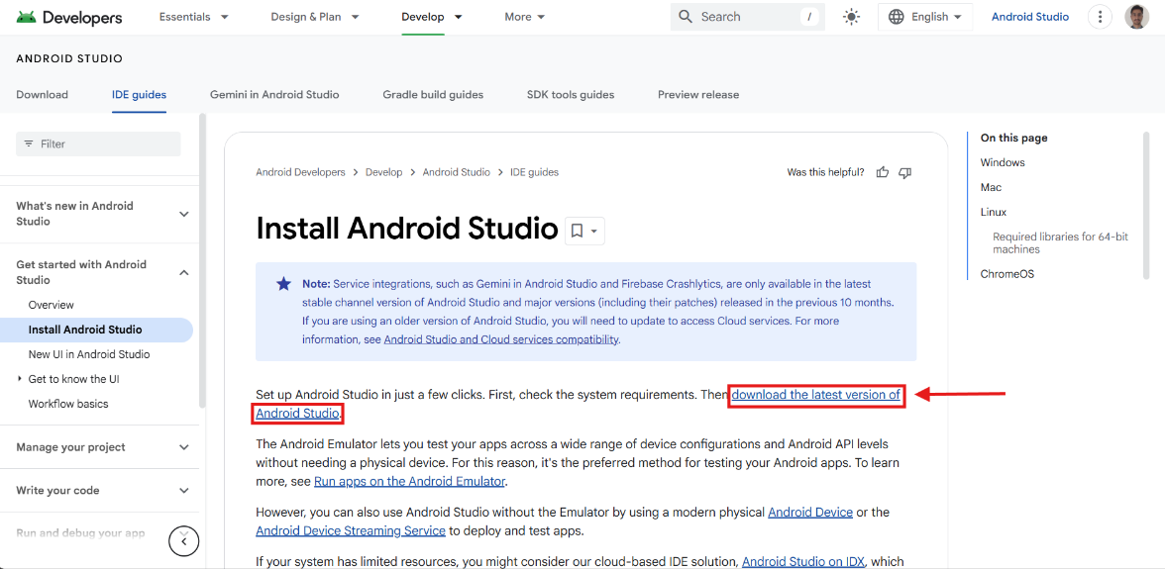
Step 5: -
Open the link and redirect to the “https://developer.android.com/studio” site
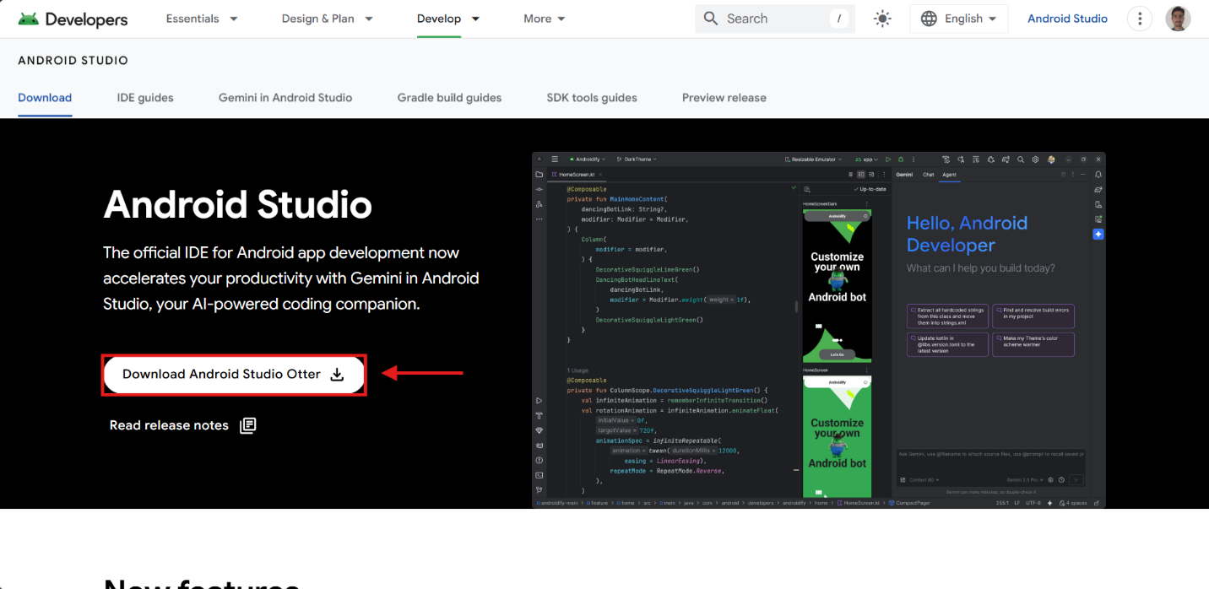
Accept the terms and conditions by checking the checkbox.
Download the latest android studio version and open the file in the File Explorer.
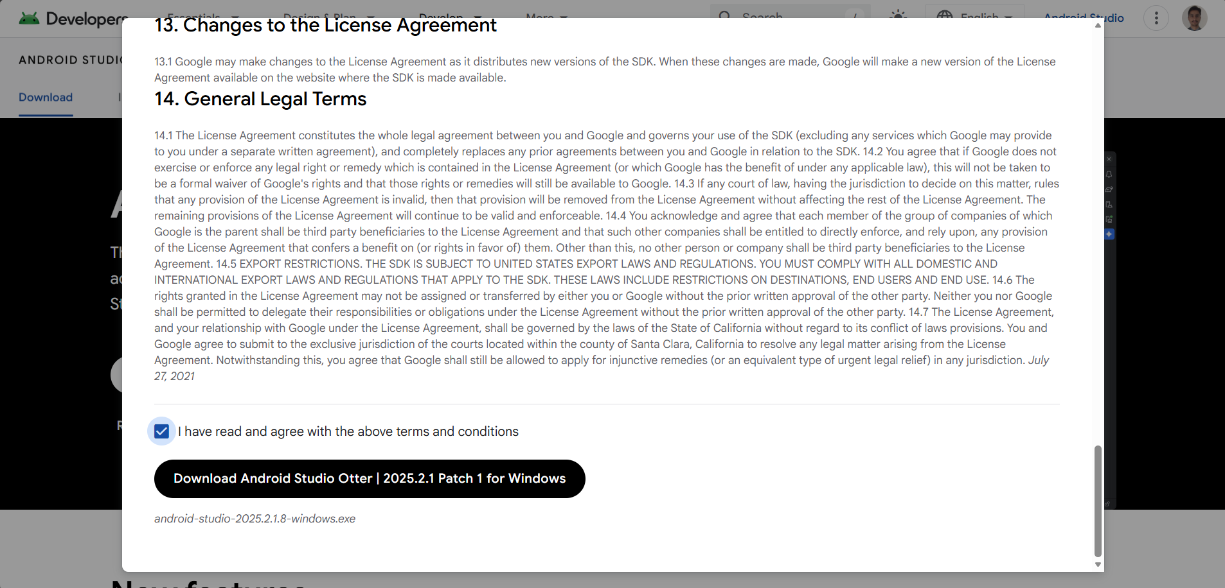
Step 6: -
Open the downloaded “.exe” file
Give the permission by pressing “yes” to the opened dialog
Then follow the steps for downloading the “Android Studio”
• Press “Next” for next 3 steps.
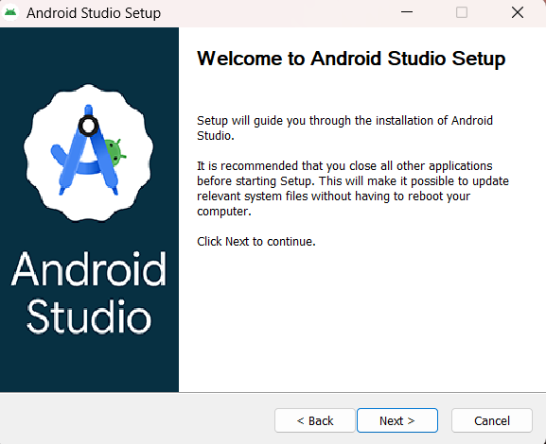
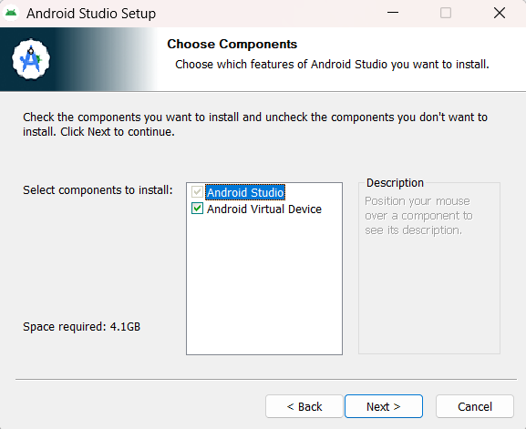
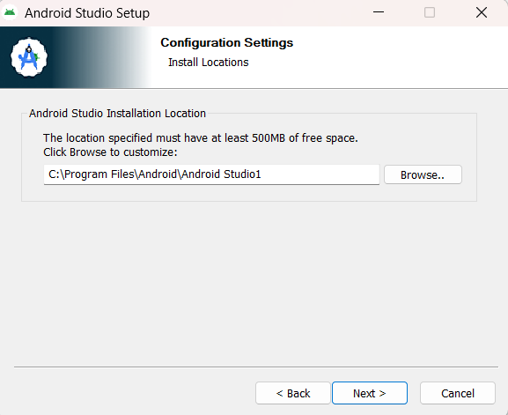
• Press “Install” keeping the default name “Android Studio”
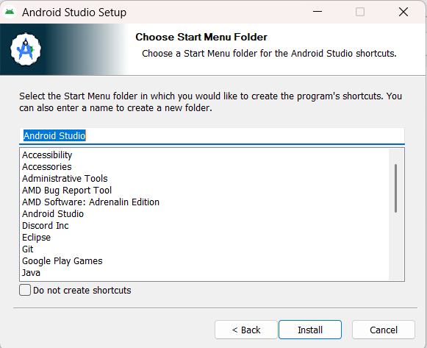
• Let the installation get complete.
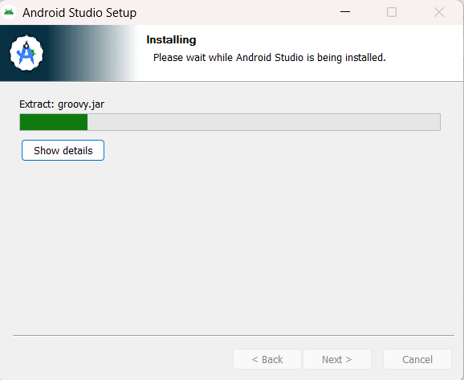
• Press “Next”
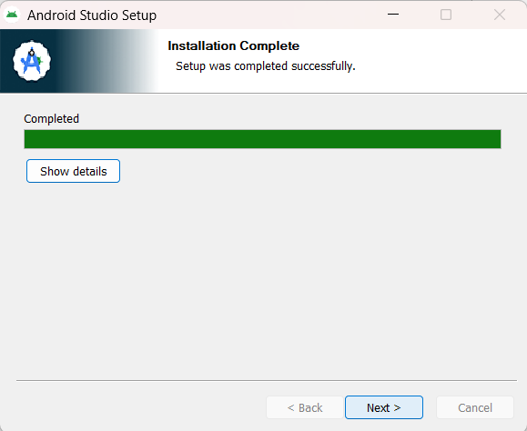
• Click the Checkbox and press “Finish”.
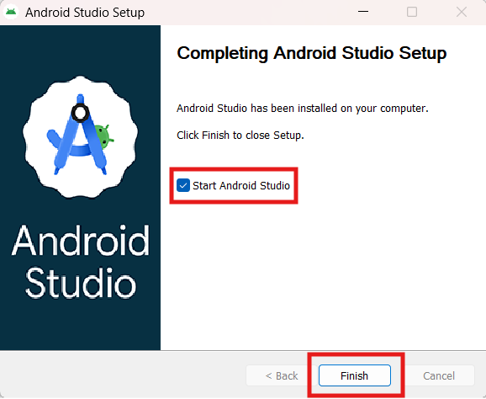
The “Android Studio” will open.
Step 7: -
• Go for “New Project”.
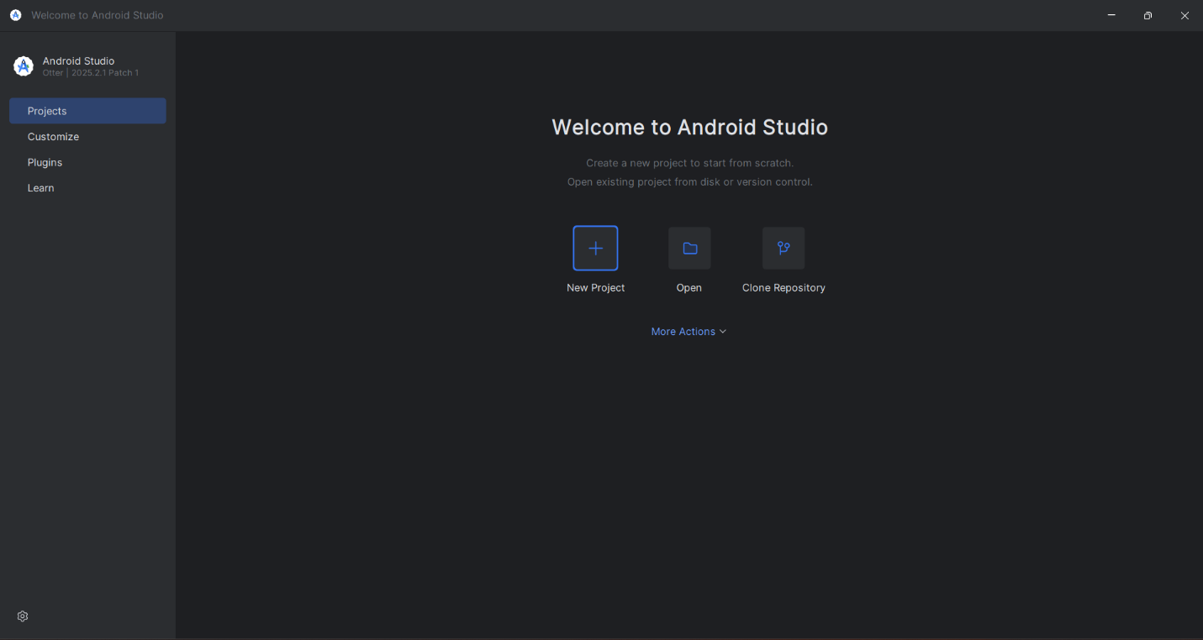
• Select “Empty Activity” and press “Next”
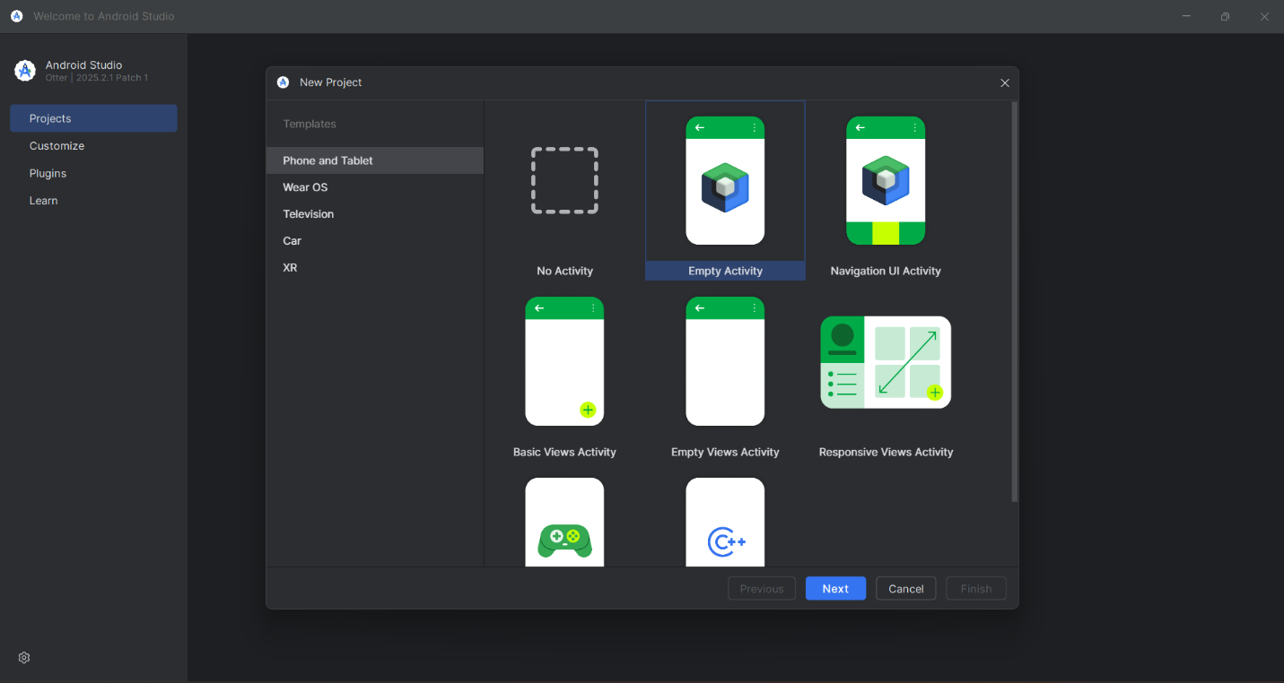
• Name your project and press “Finish”
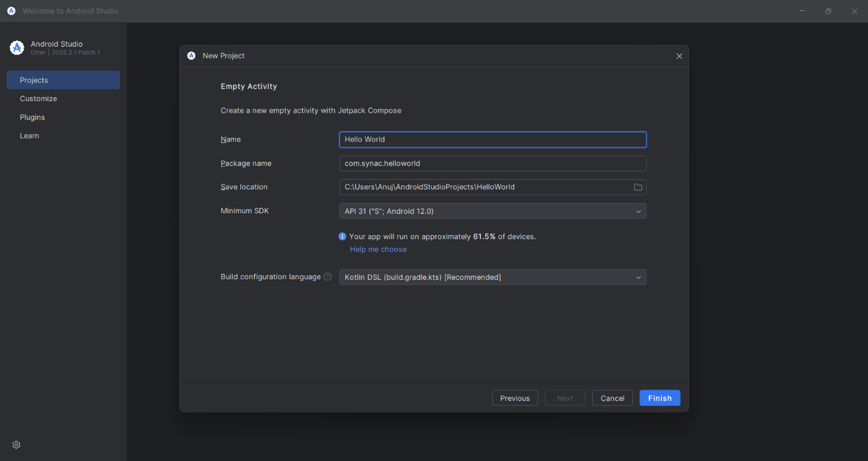

• Android Studio will create your project.
